K.SAIAJAY KUMAR - SIMPLILEARN PHASE-1 PROJECT
Project Output Screenshots:

- Console: Console with all menus for the user to choose from the options.
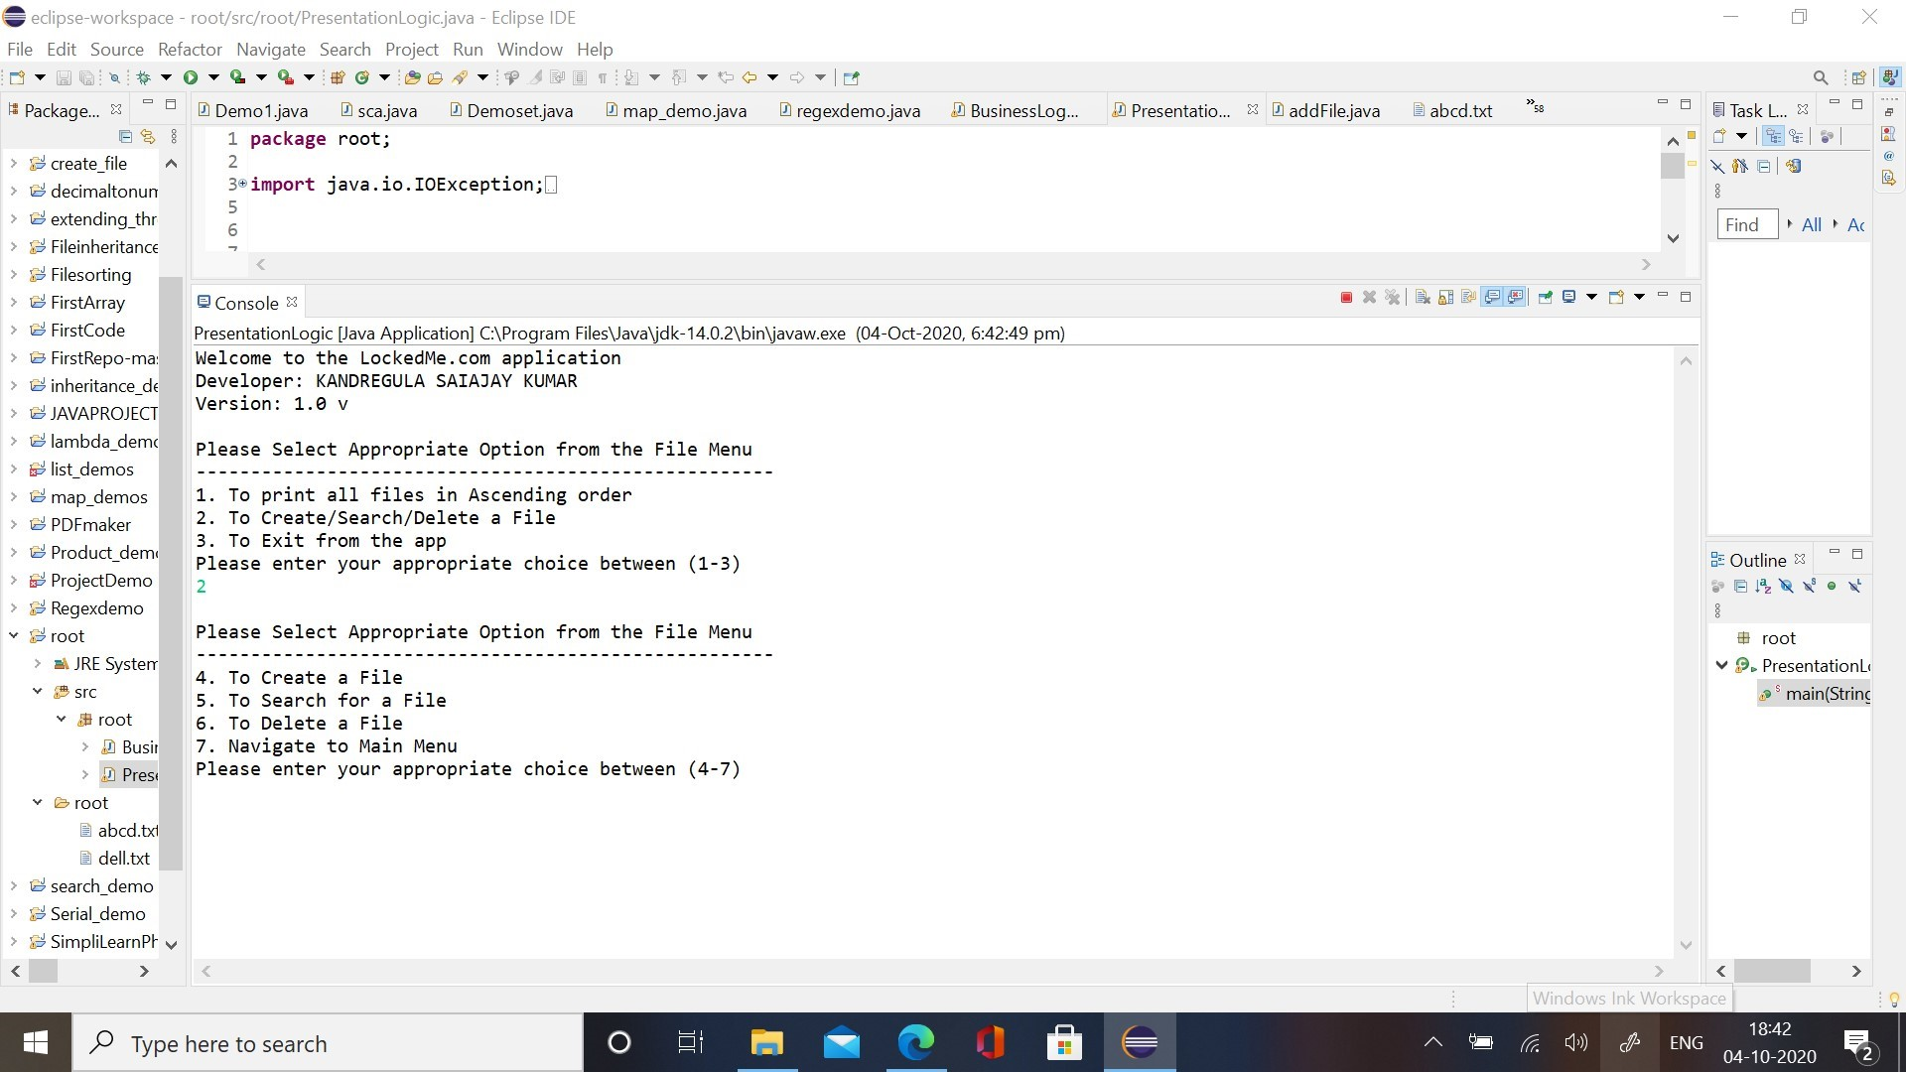

- Create File:
- To create a new file.
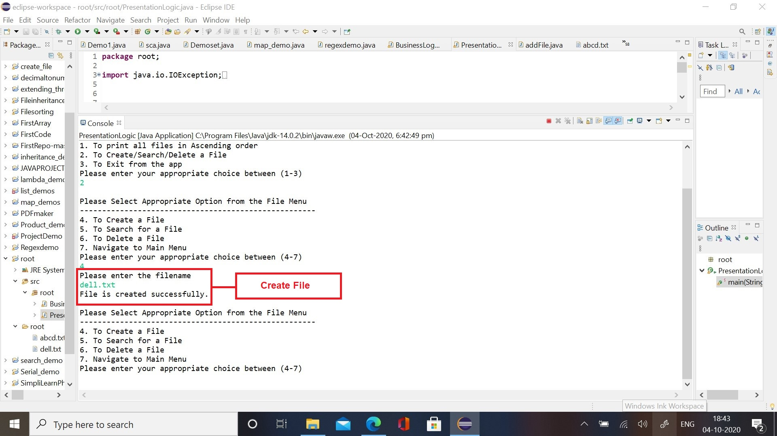

- If file already exists in the directory:
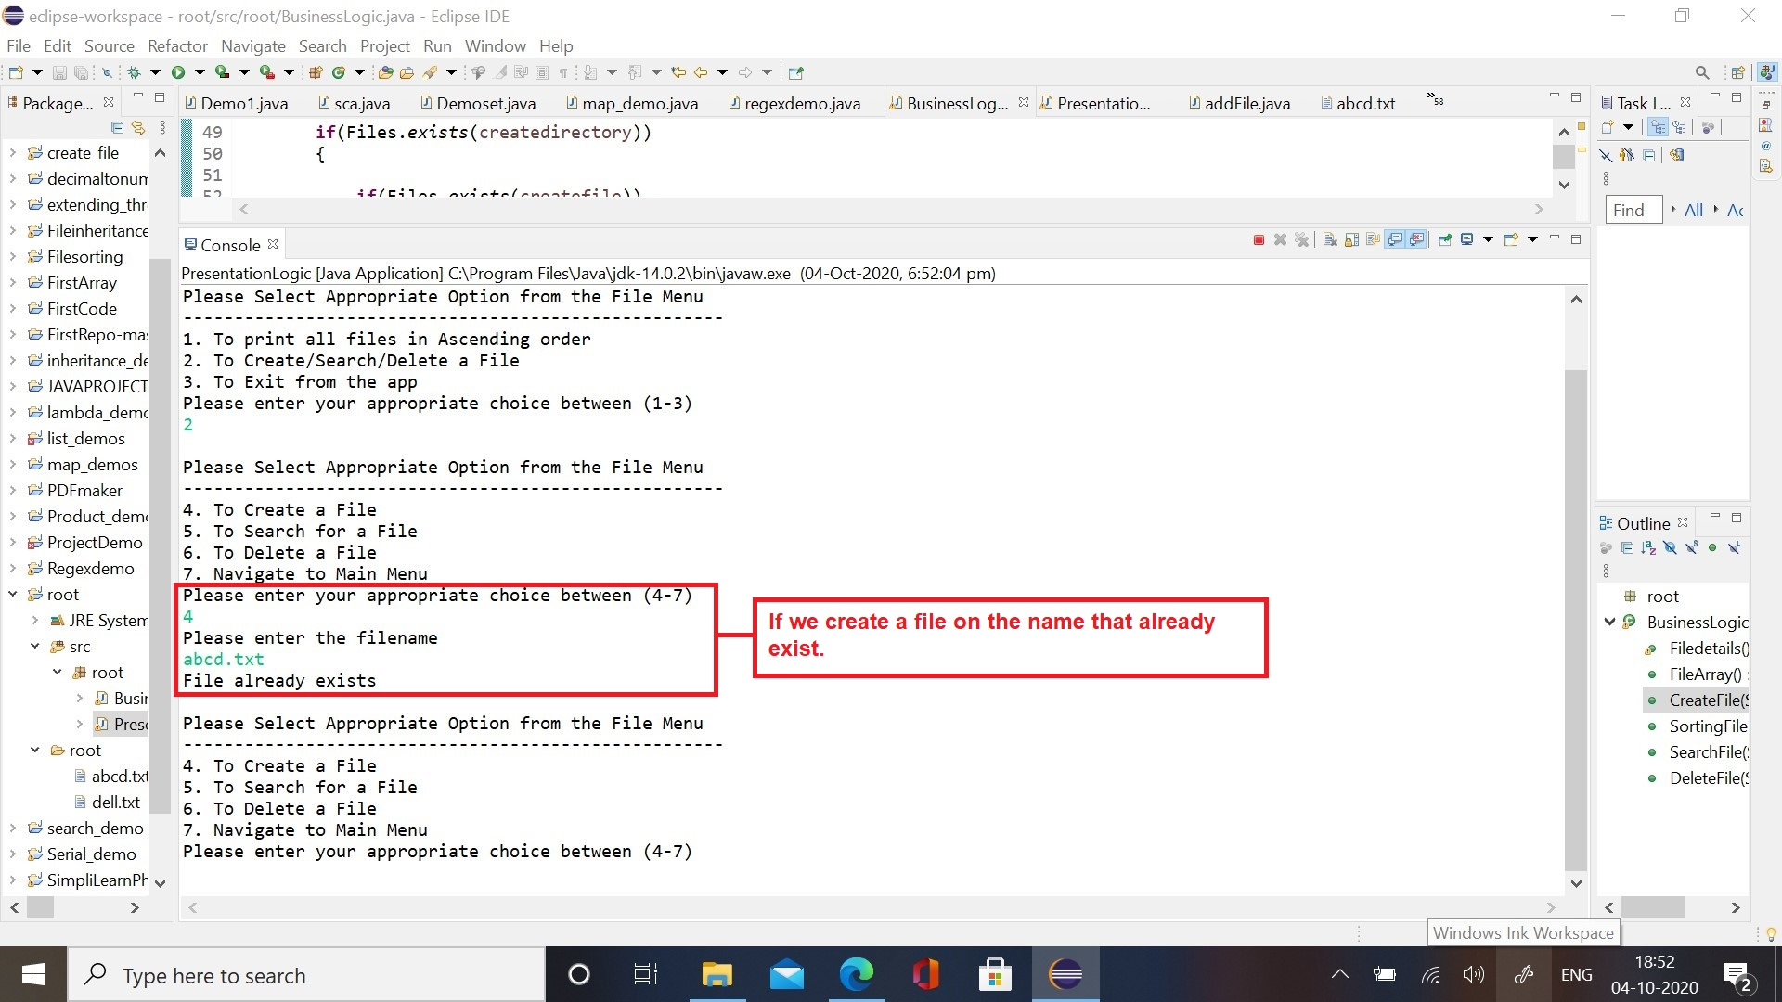

- Search File:
- Search for a file that exists in the directory:
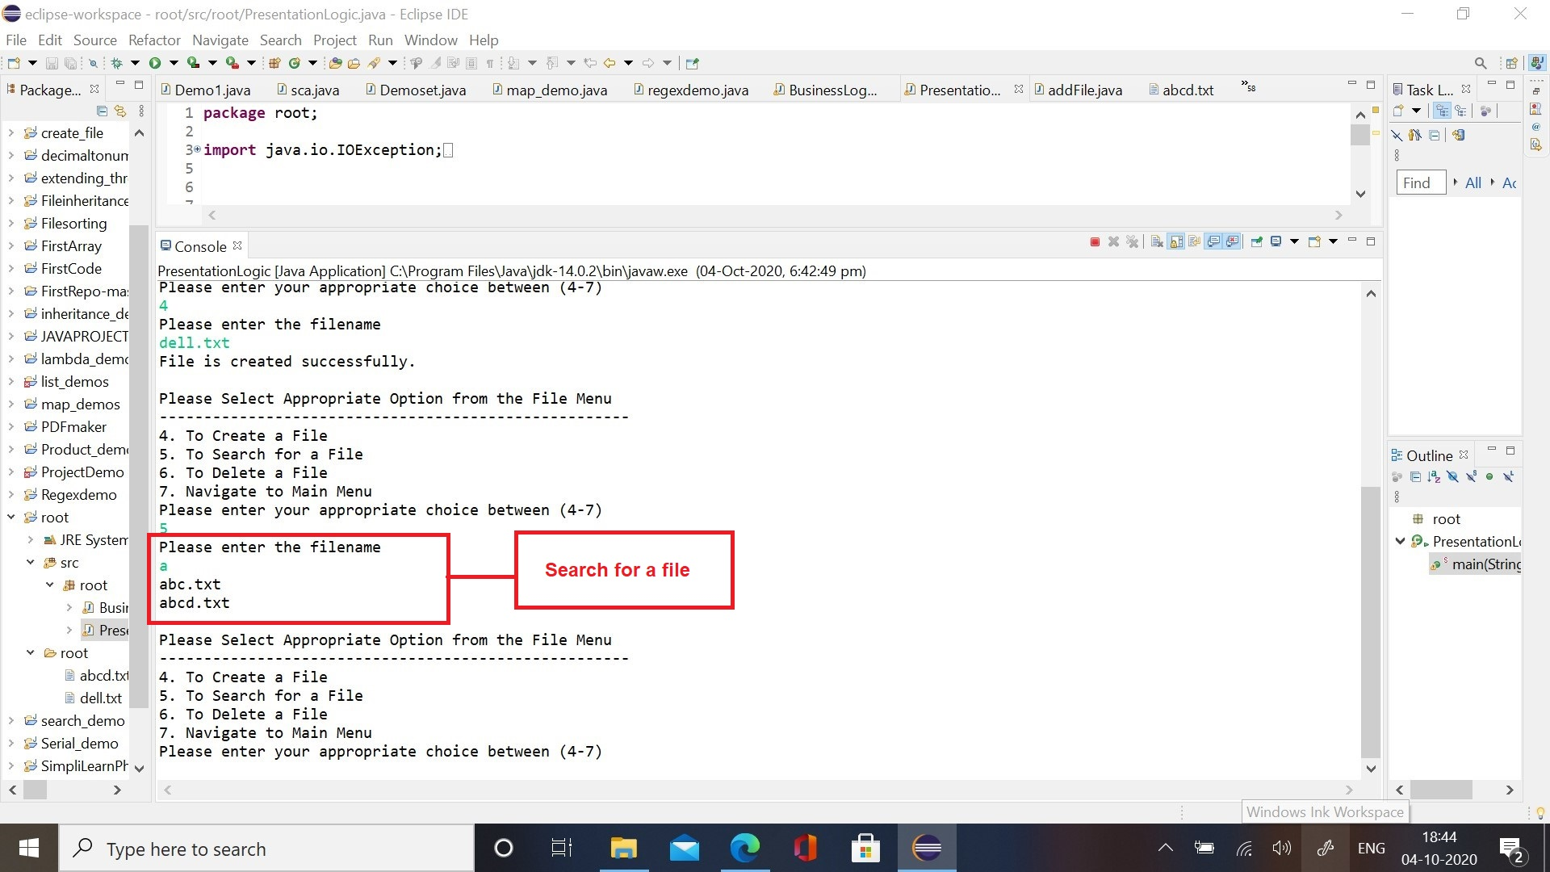
- Search for a file that does not exist in the directory:
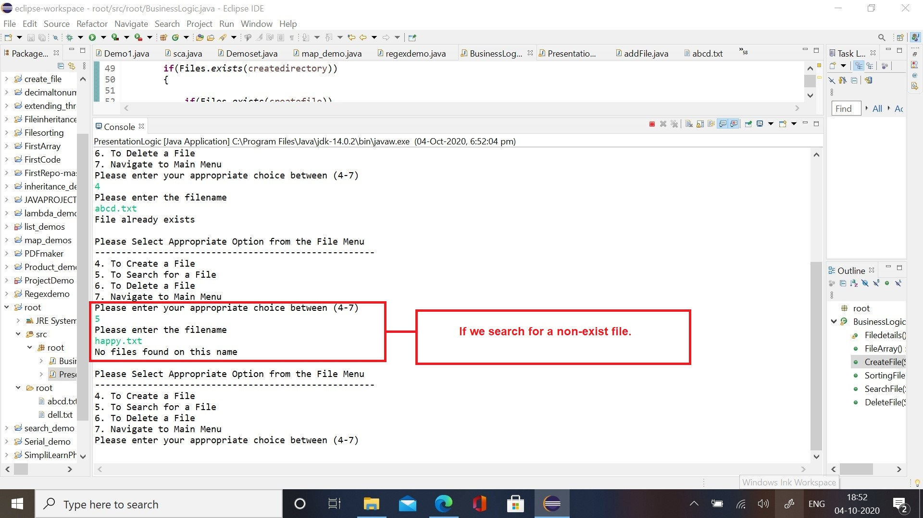

- Delete File:
- Delete a file that exists in the directory;
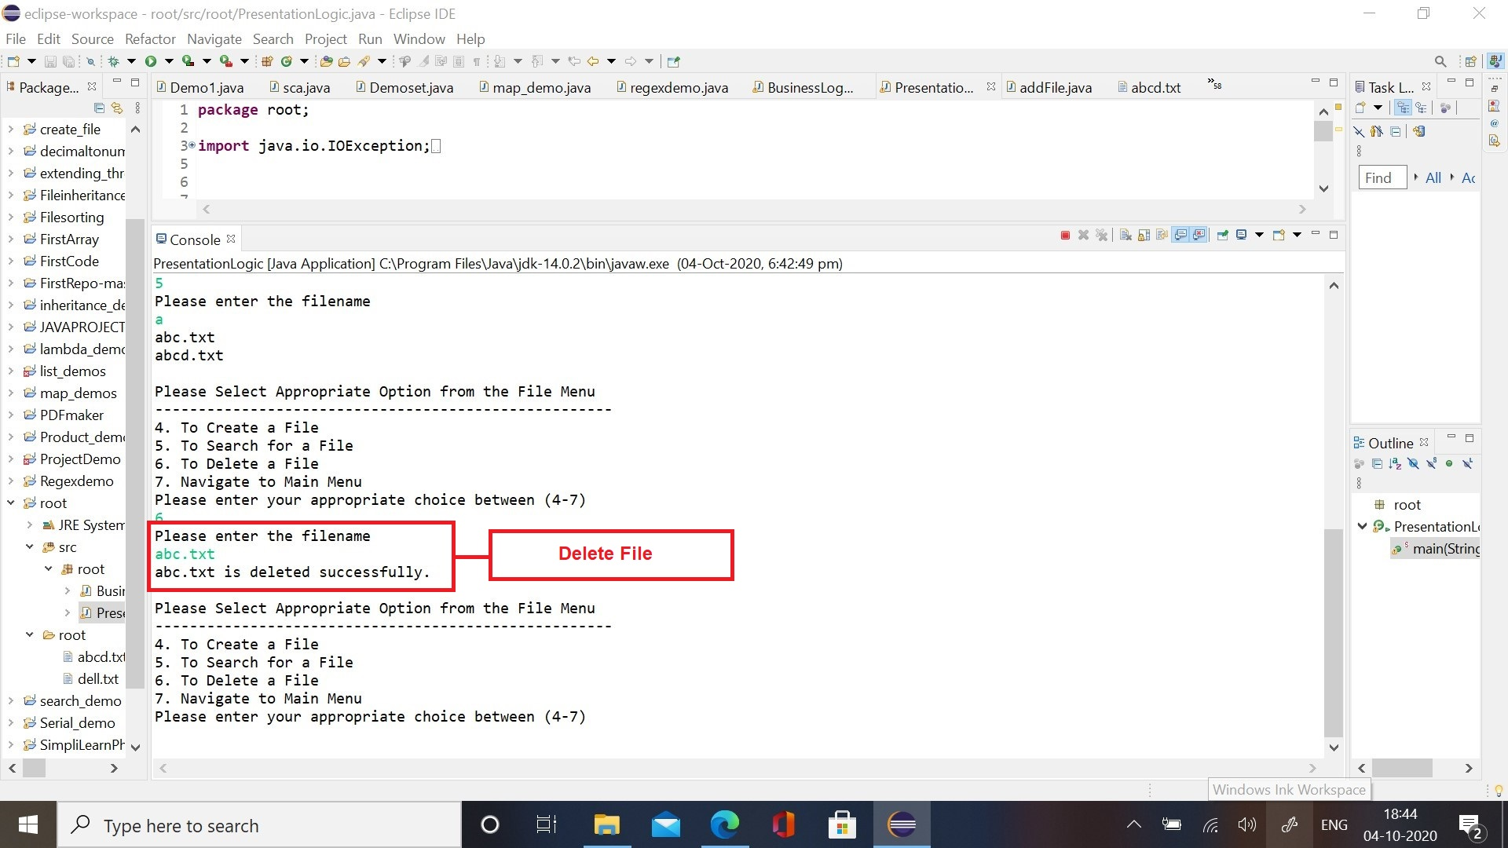

- Delete a file that does not exist in the directory:
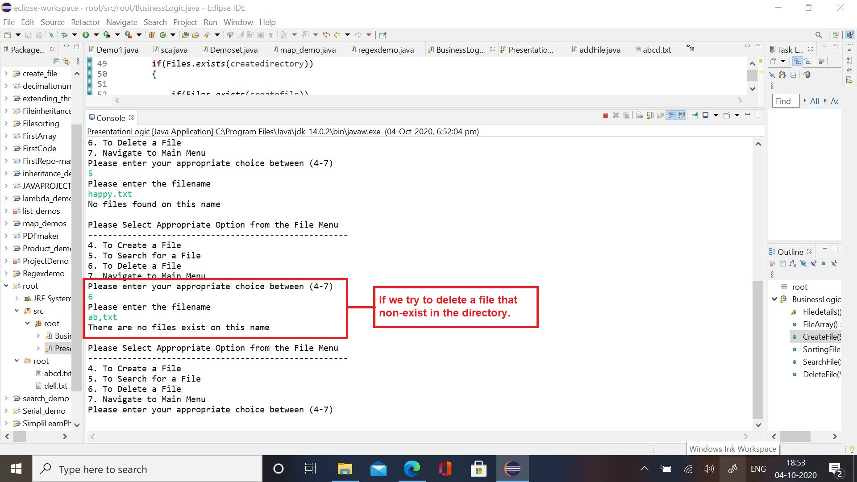

- Sort File: Sort the files in ascending order in the directory
